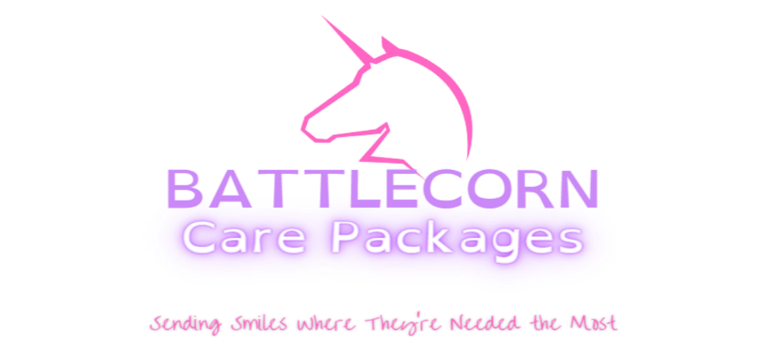

January 15, 2024
Dear Community Member,
I am contacting you representing our family’s Non-Profit organization, Battlecorn Care Packages Co. We are a local organization that focuses on enriching the days of children battling cancer, by way of care packages and awareness. In addition, we also raise funds for research and work with legislators to create positive change for the pediatric cancer community.
We are hosting our 3rd Annual Gold Tie Gala for Childhood Cancer Awareness on Saturday August 17th, 2024, at the Hilton Paper Valley in Appleton, WI and are seeking partnerships in our community to help us reach our goal of $25,000. All donations raised for and during our event will be donated to Oncoheroes Biosciences, an organization aimed at becoming the global leader in delivering new pediatric oncology drugs to our most precious patients. Last year we were able to donate a total of $25,000 towards finding better treatments and hopefully one day a cure, and this year we hope to do it once again in our fight for positive change in the pediatric cancer community.
Your partnership will help our organizations make a huge impact for children battling cancer by funding groundbreaking research, giving orphaned drugs a new life in pediatric cancers, and ensuring that a population of warriors are given the best chance possible at a long and fulfilling life.
Battlecorn Care Packages Co. would be honored to have your support in our mission to not only spread smiles, but bring awareness to childhood cancer, and give these kids a voice in their fight. Thank you for your time and consideration in assisting us in the completion of our mission through your donations of raffle items, services, and/or sponsorship.
Sincerely,
Curtis Vallier, Chief Operating Officer
https://www.battlecorncarepackages.com Sponsorship Levels:
Battlecorn Care Packages Co. Platinum: $2500 & Up
Registered 501(c)3 #85-2887239 Gold: $1000-$2499
N132 Kamkes Ave Silver: $500-$999
Appleton, WI 54915 Bronze: $249-499
920-939-0189 Friends: up to $249
Write-In: $__________
Sponsorship Levels

PLATINUM: $2500+_____  EVENT SPONSOR + FULL TABLE (8)  Recognized on All Social Media + Event Website  Recognized on T.V. & Radio Spots  Recognized at Event from Stage | GOLD: $1000-$2499_____  Full Table Sponsor (8)  Recognized on All Social Media + Event Website  Recognized on Advertisement @ Event
SILVER: $500-$999____  Half Table Sponsor (4)  Recognized on All Social Media + Event Website  Recognized on Advertisement @ Event | BRONZE: $250-$499____  2 Free Tickets  Recognized on All Social Media + Event Website  Recognized on Advertisement @ Event
FRIENDS: $0-$249_____  Recognized on All Social Media + Event Website  Recognized on Advertisement @ Event | IN-KIND: __________  Donations of Items for Use as Raffle or Auction Prizes  Recognized on All Social Media + Event Website  Recognized on Advertisement @ Event
We are so grateful for your donation and support towards reaching our goal and making a positive difference in the Childhood Cancer Community!

All funds raised from donations, sponsorships, auctions & raffles will be donated to Oncoheroes Biosciences.

Please Return Completed Form to:
Curtis Vallier
Battlecorn Care Packages Co.
501(c)3 #85-2887239
N132 Kamkes Ave
Appleton, WI 54915

For Questions:
Contact us: battlecornwi@gmail.com
Visit us: www.battlecorncarepackages.com
Call us: (920) 939-0189

